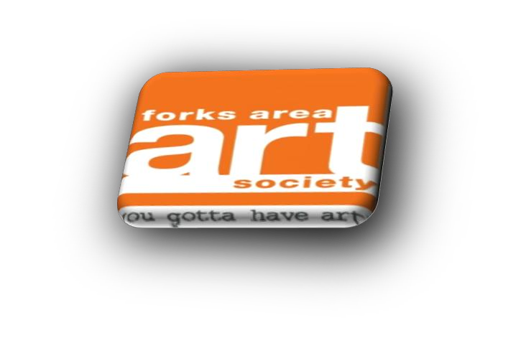

Forks Area Art Society
2022 Holiday Art Show and Sale
Park Plaza Atrium
Forks Area Art Society is hosting our third Holiday Fine Arts and Crafts Show to promote a creative community gathering of artists. Come join the fun!
Date: Saturday, November 19, 2022
Time: 9:00 am - 2:00 pm
Where: Park Plaza (Outdoor Atrium)
1800 Zucksville Road, Easton PA 18040
Contact: info@forksart.org
Welcome Artists and Fine Crafter vendors! Thank you for joining us at our 3rd Holiday Fine Arts/Crafts Show!

Details for 2022 Forks Area Art Society Holiday Art Show in the Park Plaza Atrium.
Setting: Park Plaza is located in a beautiful weather protected outdoor atrium near the Forks Township Community Park.
Set-Up time: 8:00am/Breakdown: 2:00p
Non-members: $30.00 for each space (10ft x 7ft).
Members (2022 dues paid): $25.00 for each space (10ft.x7ft)
Please Note:
* Applications are filled on a first come first served basis
** Only handmade crafts / art (No store bought crafts)
*** FAAS committee will assign booth location(s)
*** Vendors are responsible for providing lights, tables, chairs, and any other items needed
Registration Deadline:
Registrations will be accepted until November 12. If additional time is needed to register, please email us to determine if space is available. Space is limited! Upon receipt of your completed application and payment, you will receive an email confirming your space in Park Plaza. Please bring it with you when you check-in at the REGISTRATION TABLE upon your arrival.
As a participating artist, craftsman, or vendor you should......
PLEASE READ THE FOLLOWING RULES AND REGULATIONS CAREFULLY:
1. You must check in at the registration table and confirm your space upon arrival.
2. Set-up and take down: Set-up time will begin at 8:00am and take-down time will begin at 2:00pm.
3. By signing and submitting this application, I/We agree to release and hold harmless to FAAS and its board, staff, Forks Township, related agencies and persons from responsibility for all personal damage to material, equipment, person, lost property or stolen. All booths must be manned for the duration of the event.
- All artists and craftsmen are responsible for cleaning up their area at completion of event.
5. All artists, craftsmen accept responsibility for submitting all taxes due to the city, state, or federal government.
6. Parking is the responsibility of the vendors and others.
7. Inappropriate behavior will not be tolerated. This includes foul language and harassing other individuals. If you or any members of your team are found to be acting inappropriately, it will result in removal of the individual from the event and closure of your booth without refund. This is to be a fun day for you and all people who are coming to see you and the others.
8. No alcoholic beverage
9. There is limited access to electricity. If you require electricity for your booth please let us know when you submit your registration form.
10. You are requested to carry/haul your items to your space and are responsible for cleaning up your area at the completion of the event. Any grease disposal or hazardous substances will be the responsibility of the vendor.
11. Forks Area Art Society or Forks Township are not responsible for lost, stolen or damaged material, equipment, or personal property.
Please retain the top portion of this form for your information.

Application Form follows on the next two (2) pages.

2022 Forks Area Art Society Holiday Art Show
Saturday Nov.19, 2022 (Rain or Shine) – 9:00am – 2:00pm
Park Plaza Atrium, 1800 Sullivan Trail, Easton PA. 18040
Please Print. Detach and mail to: Forks Area Art Society, 1290 Hawthorn Dr, Easton PA 18040
Application for vendor space:
Name: __________________________________________
Phone: ( ) _____ - ________
Address: _________________________________________
City: _____________________ State: _________ Zip:__________
Email address____________________________
Check one:
( ) Member (dues paid for 2022) #____ of spaces
@ $25.00ea
( )Non-member #__of spaces @$30 ea

Please make all checks payable to “Forks Area Art Society” Check # _____ Your cancelled check is your receipt. You will also receive a confirmation by email.
Total due $____________
( ) Please check here if you require electricity for your booth.

I have read the rules and regulations and understand that any infraction of them will result in my removal from grounds without a refund.
Signed: _______________________________________________ Date:_________________
**** Please give brief description/photos of the items you will be displaying/selling at Holiday Art Show.

