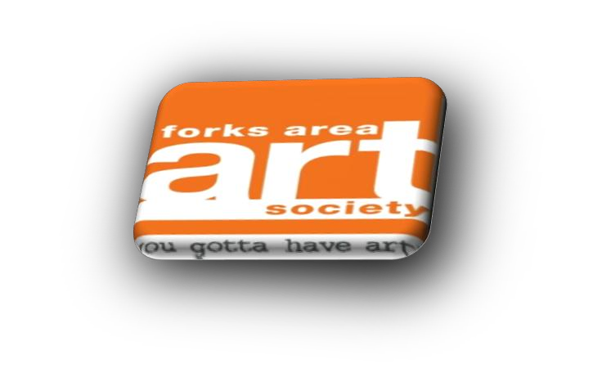

Forks Area Art Society
2021 “Artoberfest!”
Art in the Park
Forks Area Art Society is hosting our seventh outdoor art festival to promote a creative community gathering of artists. Come join the fun!
Date: Saturday October 9, 2021 (Rain date: Oct. 10)
Time: 10:00 am - 4:00 pm
Where: Meuser Park
22nd & Northampton Sts, Wilson Borough PA 18042
Contact: info@forksart.org
Welcome Artists/Craftsmen/Vendors! Thank you for joining us at Artoberfest!

Details for 2021 Forks Area Art Society “Artoberfest” Art in the Park:
Set-up time: 8:00 am /Break down: 4:00 pm (No one will be allowed on the grounds before this time to set-up).
Non-members: $40.00 for each 12x12 space.
Members (2021 dues paid): $30.00 for each 12x12 space.
Food Vendor – Business Flat Fee: $50.00 for each 12x12 space on the macadam.
Please Note:
* Applications are filled on a first come first served basis
** Only handmade crafts / art (No store bought crafts)
*** FAAS committee will assign booth location(s)
*** Vendors are responsible for providing tents, lights, tables, chairs, and any other items needed
**** In the event of questionable weather we will email an update to our mailing list but please check the website, www.forksart.org, or our Forks Area Art Society Facebook page for festival updates.
Registration Deadline: September 25, 2021. Upon receipt of your completed application and payment, you will receive an e-mail confirming your space in the park. Please bring it with you when you check-in at the REGISTRATION TABLE upon your arrival.
Cancellation by vendor: Will be accepted and fees will be refunded if written notice is received from the vendor before September 25.
As a participating artist, craftsman, or vendor you should......
PLEASE READ THE FOLLOWING RULES AND REGULATIONS CAREFULLY:
1. You must check in at the registration table and confirm your space upon arrival.
2. Set-up and take down: Set-up time will begin at 8:00am and take-down time will begin at 4:00pm.
3. By signing and submitting this application, I/We agree to release and hold harmless to FAAS and its board, Wilson Borough officials and staff, related agencies and persons from responsibility for all personal damage to material, equipment, person, lost property or stolen. All booths must be manned for the duration of the event. All tents, artwork, supplies, tables, chairs, etc. must be secured while on the premises.
- All artists, craftsmen and vendors are responsible for cleaning up their area at completion of event.
5. All artists, craftsmen and vendors accept responsibility for submitting all taxes due to the city, state, or federal government.
6. Parking is the responsibility of the vendors and others. You may park along Northampton St. or either macadam driveway at each end of the park while setting up. When done, move your vehicle to the pool parking lot at the back of the park. Staff will be present to guide you to parking area.
7. Inappropriate behavior will not be tolerated. This includes foul language and harassing other individuals. If you or any members of your team are found to be acting inappropriately, it will result in removal of the individual from the event and closure of your booth without refund. This is to be a fun day for you and all people who are coming to see you and the others.
8. No alcoholic beverages.
9. No overnight campers, vans, trailers, etc., are allowed in the park.
10. There is no access to electricity or water.
11. You are requested to carry/haul your items to your space and are responsible for cleaning up your area at the completion of the event. Any grease disposal or hazardous substances will be the responsibility of the vendor. You may use the parking near the pool area after setting up. Vendors preparing and selling food will be required to have a temporary or permanent food license and Serve Safe certification/insurance. You can contact the department of agriculture at 610-489-1003 or website www.agriculture.state.pa.us.
12. Forks Area Art Society and Wilson Borough are not responsible for lost, stolen or damaged material, equipment, or personal property.
Please retain the top portion of this form for your information.

Application Form follows on the next page.

2021 Forks Area Art Society “Artoberfest!” Art in the Park Saturday October 9, 2021(Rain date October 10) - 10:00 am - 4:00 pm
Meuser Park, 22nd & Northampton Sts. Easton, PA. 18042
Please Print. Detach and mail to: Forks Area Art Society, 1290 Hawthorn Dr, Easton PA 18040
Application for vendor space: Payment may be made by check or Go Fund Me account located on the FAAS website.
Name: __________________________________________
Phone: ( ) _____ - ________
Address: _________________________________________
City: _____________________ State: _________ Zip:__________
Email address____________________________
Check one:
( ) Non-member # ____ of spaces 12x12 @ $40.00 each
( ) Member (dues paid for 2021) #____ of spaces
12x12 @ $30.00 each
( ) Food vendor #____ of spaces12x12 @$50.00 each
Please make all checks payable to “Forks Area Art Society” Check # _____ Your cancelled check is your receipt. You will also receive a confirmation by email.
Total due $____________
I have read the rules and regulations and understand that any infraction of them will result in my removal from grounds without a refund.
Signed: _______________________________________________ Date:_________________
**** Please give brief description of the items you will be displaying/selling at Art in the Park

